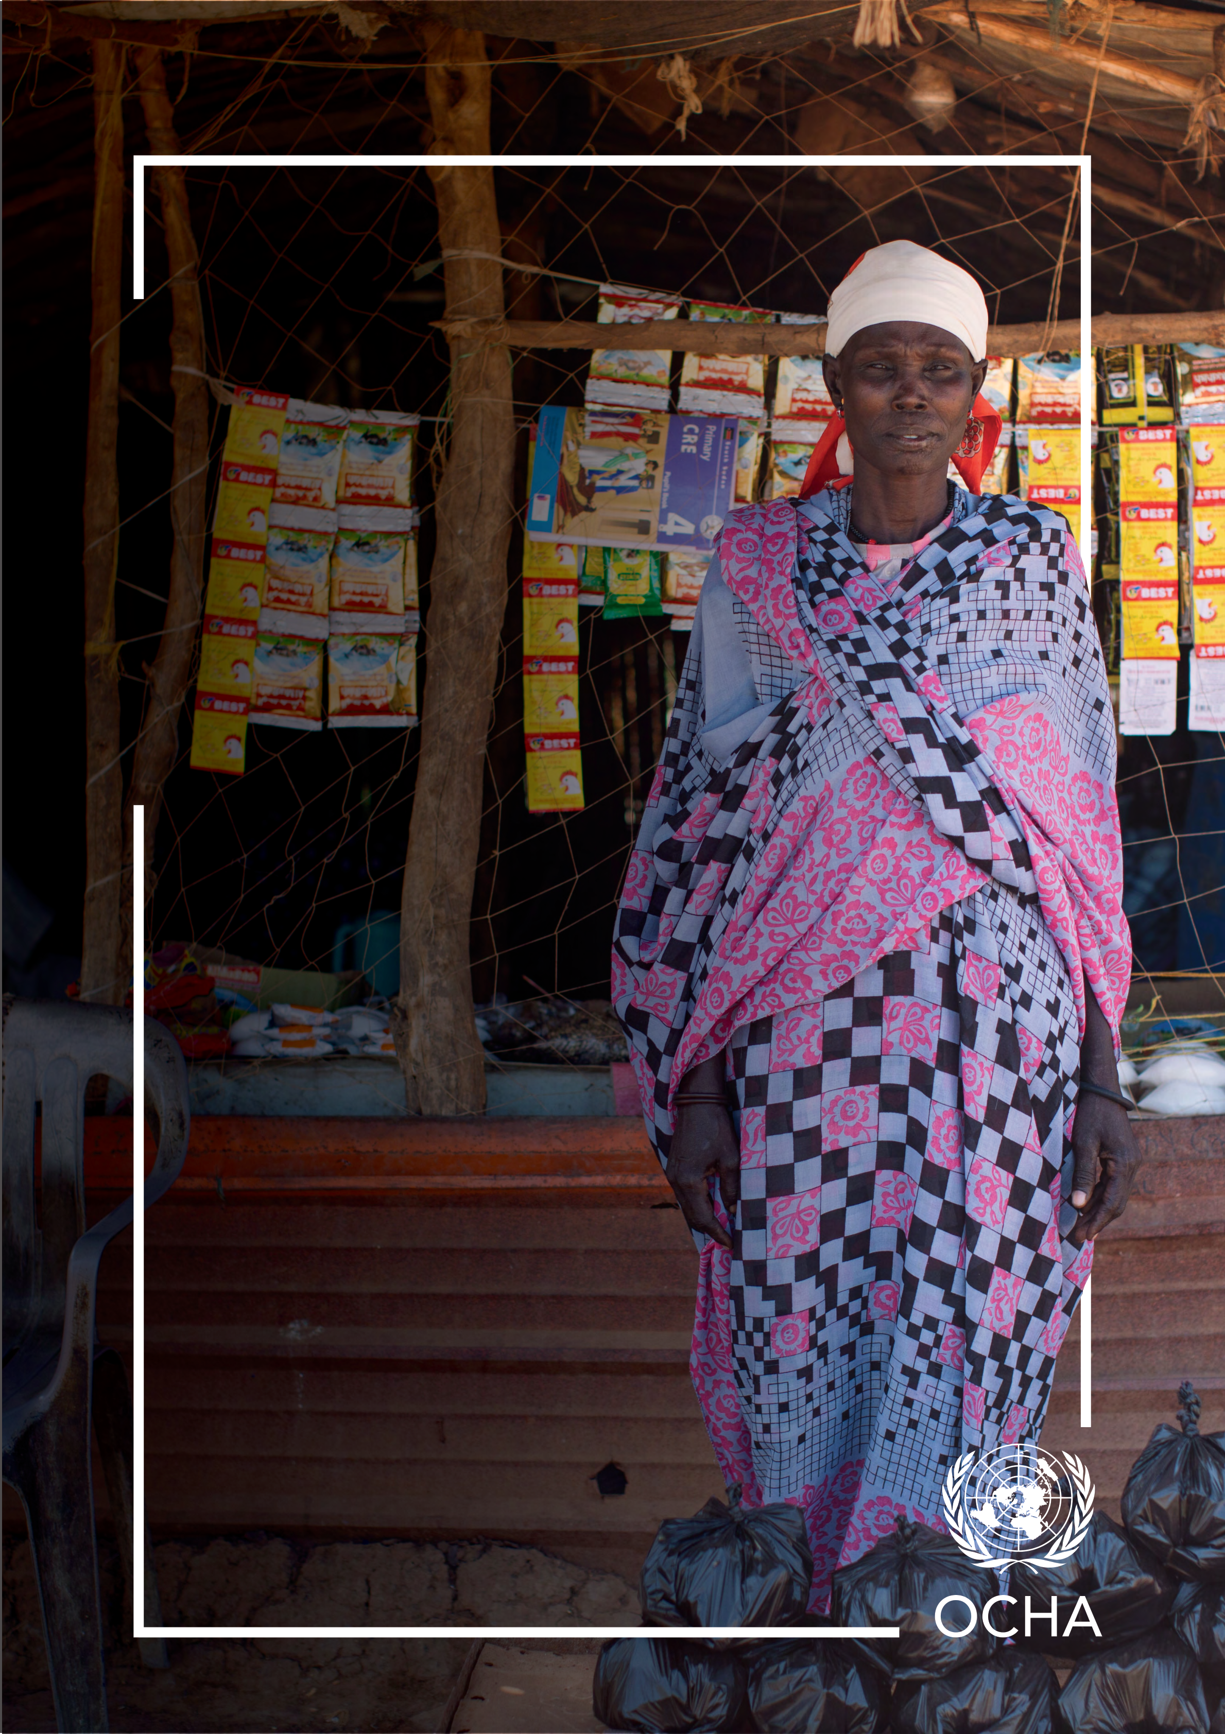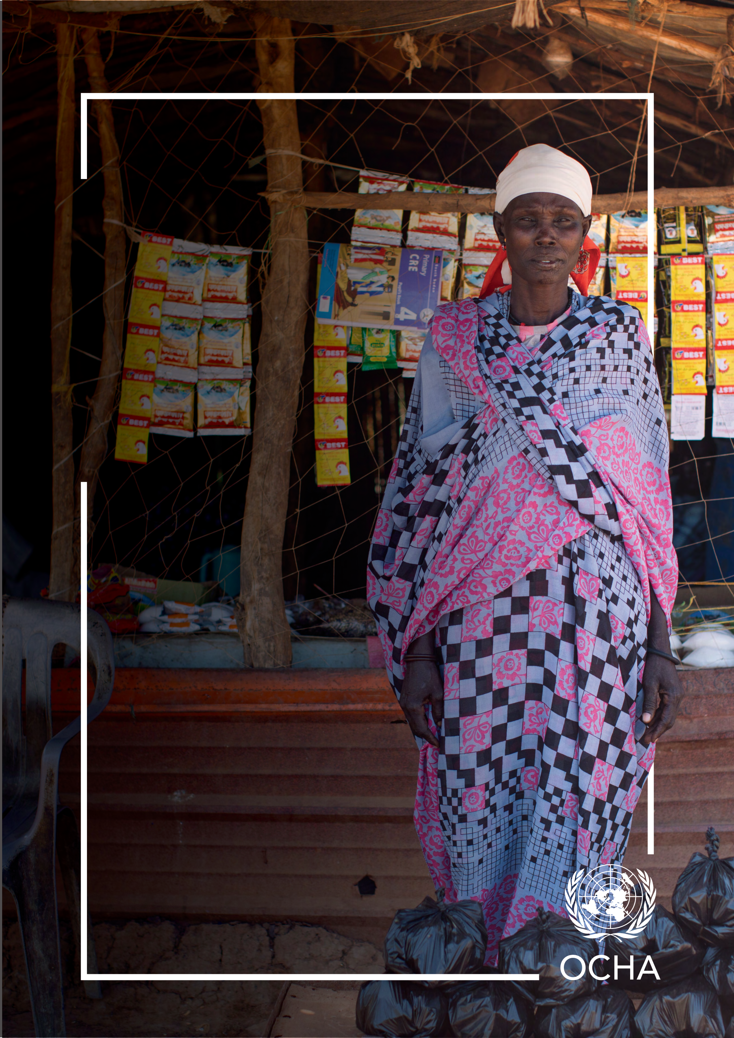

**INNOVATING**   
**ANTICIPATORY ACTION**   
LESSONS FROM THE 2022 SOUTH SUDAN FLOODS

**1**

**Credits**

Cover photo: A portrait of Nykuoth Gatdet Bol, 42, outside her shop. She was displaced by floods from Guit County and now lives in the Bentiu IDP site D. With cash assistance from CERF she started a business selling fish in Rubkona and Bentiu markets. She earns over 15,000SSP daily as profit, with which she is able to pay her children’s school fees and meet her basic needs. Credit: OCHA/Sarah Waisna

Content:   
**Kate Katch**, kate.katch@un.org

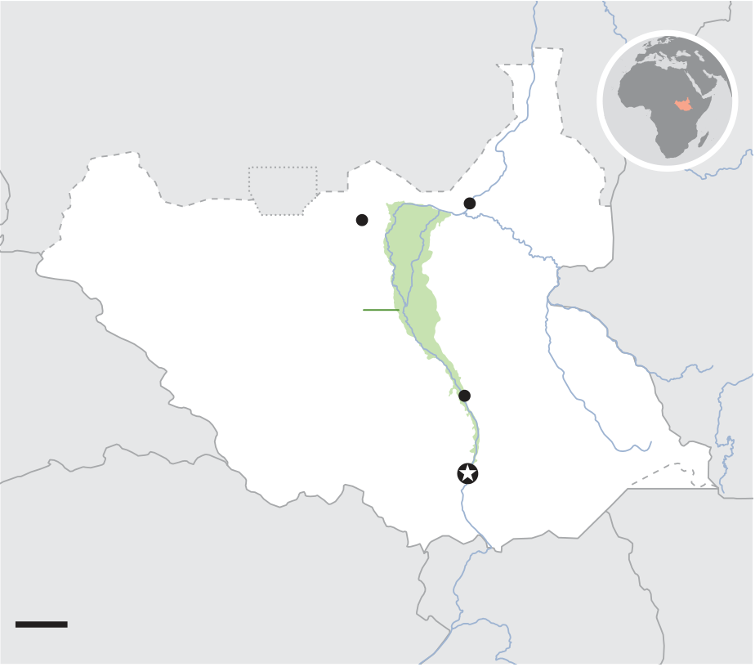

**Innovating Anticipatory Action:** Lessons from the 2022 South Sudan Floods

More reliable weather and vulnerability forecast- **The challenge**

ing means there is more opportunity than in past

decades to limit the humanitarian impact of certain shocks. Taking action in advance of a crisis, before either the shock or its peak impact, is known in the humanitarian sector as anticipatory action. In es-sence, anticipatory action makes acting the default when risks, not needs, increase.

A predictive model or forecast that can be used to trigger pre-agreed action plans and pre-arranged finance is at the heart of anticipatory action. Ideally, all these elements can be captured in a single   
framework document that serves as a ‘rulebook’ for how anticipatory action is supposed to work for a specific shock, in a specific context. But what happens when there is insufficient forecast data available, or the complex operating environment in the country requires more time to prepare and respond? Is it still possible for the humanitarian community to be anticipatory and for the UN   
Central Emergency Response Fund (CERF) to   
release funds ahead of an impending crisis?

At the beginning of 2022, communities across   
South Sudan were suffering from three years of unprecedented flooding. Floods had become a   
year-round struggle, exacerbating an already dire humanitarian situation, where more than two-thirds of the population (almost 9 million people) needed humanitarian assistance.**1** Ongoing conflict and instability in the country combined with the flooding resulted in people being forced to leave their homes time and time again.

In March 2022, OCHA explored the feasibility of developing an Anticipatory Action Framework to get ahead and mitigate the impact of severe floods. OCHA’s Centre for Humanitarian Data explored the available data and forecasts that could be used to develop the trigger mechanism for a framework. However, the predictive strength of forecasts usual-ly used to provide information on future large-scale flooding was limited for South Sudan.

|  |  |  |  |  |  |
| --- | --- | --- | --- | --- | --- |
| This was the situation facing South Sudan in 2022. | S | U | D | A | N |
| Through creative thinking and the decision to pilot |

a new approach, the UN Office for the Coordination

|  |  |  |  |  |
| --- | --- | --- | --- | --- |
| of Humanitarian Affairs (OCHA) discovered the | *Abyei* | | Malakal | E T H I O P I A |
| Bentiu | |
| answer is yes. |
| *Sudd wetlands* | |
| As Joyce Msuya, Assistant Secretary-General |
| for Humanitarian Affairs and Deputy Emergency | CENTRAL  AFRICAN  REPUBLIC | **S O U T H**  **S U D A N** | Bor | KENYA |
| Relief Coordinator concluded, “The takeaway is |
| clear: anticipatory action works for climate-related | **Juba** |
| shocks in South Sudan, but also elsewhere, includ- |
| DEMOCRATIC REPUBLIC | |
| ing in Mozambique as I saw during my recent visit. |
| U G A N D A |
| Government-OCHA collaboration on early warning, | OF THE CONGO | |
| combined with proactive community engagement, | 100km | |

saved lives and resources. This cost-effective, flexi-ble approach helps minimize suffering.”

1 OCHA, South Sudan Humanitarian Response Plan, 2022.

**3**

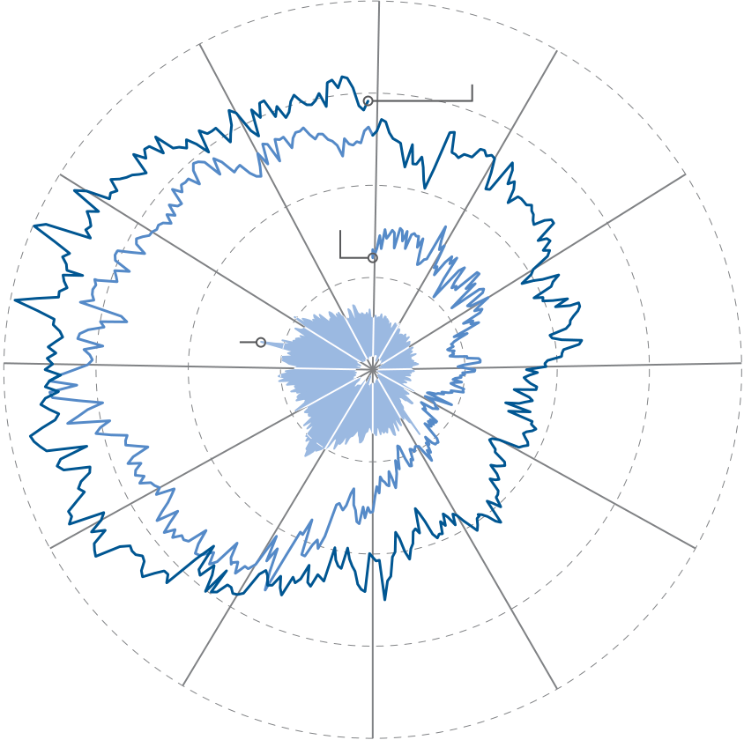

The complex nature of the Sudd wetland’s ecosys-tem meant that even where data was available and trends could be observed, there was no clear corre-

**Flooded area around the Sudd wetlands in percentage (1998-2022)**

|  |  |  |
| --- | --- | --- |
| lation with flooding. With no forecast available that | 20% | **2022** |
| could provide a trigger for time-bound actions, an | 15% |

Anticipatory Action Framework would not be viable.

|  |  |  |  |
| --- | --- | --- | --- |
| There was another challenge. Even if the data was | **1998-2020** | **2021** | 10% |
| available, traditional flood models typically forecast | 5% |
| only 1 or 2 weeks ahead. In a complex operating |
| environment like South Sudan, this may not provide |

humanitarian actors and communities with enough   
time to prepare. Many supply routes were already   
submerged from the 2021 floods making preposi-  
tioning supplies difficult, time consuming, and fully   
dependent on air travel.

While the data infrastructure was inadequate to   
create a predictive model or forecast, the Centre’s   
analysis confirmed there was enough information South Sudan Sudd wetlands flood levels, January 1998 to April 2022, to indicate a significant flood was looming. using AER Floodscan data.

Typically, during the dry season, flood waters retreat into the Nile and other river basins, drying out the land and preparing for a new rainy season. Howev-er, the flood waters from 2021 never receded and remained above the highest levels observed in over 20 years. Any new rains expected for 2022’s rainy season would turn an already dire situation disas-

In Unity State, the flooding was expected to put more than 320,000 people — over a third of whom were already displaced — at risk of further displace-ment, loss of livelihoods, disease outbreaks, food insecurity and psychological distress.

Over 125,000 people living in the Bentiu internally

torous. displaced persons (IDP) camp and in informal

camps in Bentiu town were particularly vulnerable

As Seth Caldwell from OCHA’s Centre for Human-itarian Data observed, “The water levels were be-yond anything seen, and that was before the 2022 rainy season had begun.”

In-country humanitarian and environmental experts agreed that even with a normal rainy season, there was extreme risk it would bring widespread floods beyond the levels seen in 2021 and likely at or   
beyond the scale of a 1 in 50-year event. Without

and at risk. Since 2021, the Bentiu area had been surrounded by floodwater creating an island, cut off from dry land and roads, protected by kilome-ters of hurriedly constructed dykes. Roads to bring relief items or evacuate people from flooded areas were inundated. With very limited opportunity for livelihoods and reduced access to aid, people were extremely food insecure — at times resorting to eating water lilies. Even a relatively small increase in the water level or a dike breach would have cata-

intervention, such an event could lead to drastic lev- strophic impacts.

els of need for affected populations, many of whom

were already experiencing an extreme lack of food and had exhausted all coping mechanisms.

2 OCHA Mission Report to South Sudan, 2022.

**4**

The humanitarian community had merely a few weeks, perhaps months, to prepare before the rainy

2022 rainy season**3** and months sooner than had been the case in response to the 2020 and 2021

season began. floods.

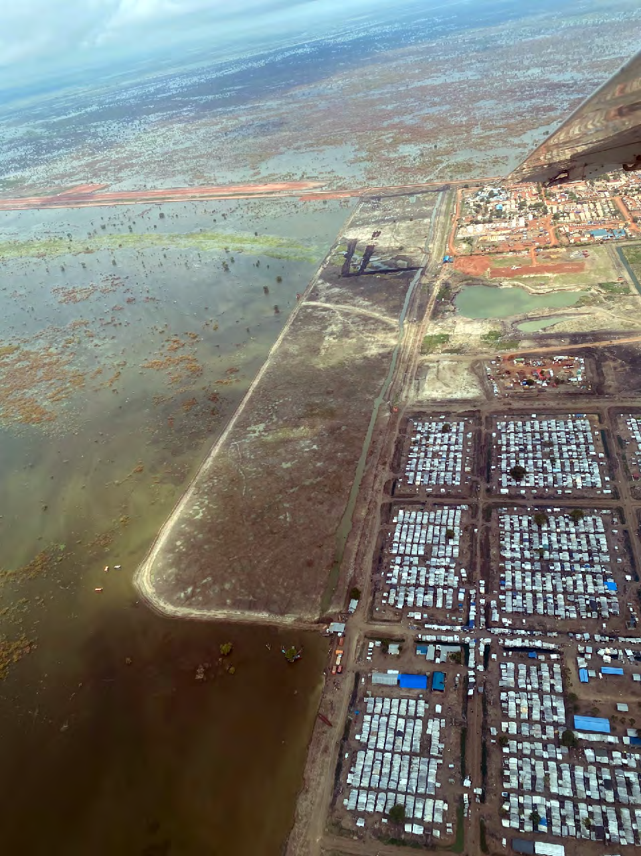

Flood extent, Bentiu town and IDP camp with airport strip in background (June 2022). Credit: OCHA/Rawad El Zir

**The solution**

OCHA saw an opportunity. Pilot a lighter and nim-bler approach to anticipatory action, where CERF allocations can be provided earlier in countries with protracted crises based on a high likelihood of that country experiencing an additional shock that would compound existing humanitarian needs.

Consequently, CERF did not need to wait for the floods to destroy the homes and lives of people in Bentiu. Instead, CERF pulled the response forward by allocating US$15 million, complemented by an additional $4 million from the South Sudan Human-itarian Fund (SSHF) in May 2022, well ahead of the

3 OCHA, [CERF Press Release](https://cerf.un.org/sites/default/files/resources/OCHAPressReleaseSouthSudanFloodsEarlyAction070522.pdf), 7 May 2022.

4 South Sudan, [public project tracker](https://data.humdata.org/dataset/cerf-early-action-monitoring-framework-2022).

Alongside the funding, Sara Beysolow Nyanti, Resi-dent and Humanitarian Coordinator in South Sudan, put in place decision-making as close to the people of Bentiu as possible. A high-level special task   
force was established with senior representatives in Bentiu to consult with communities on their pri-orities and to oversee operations. The placement of the task force in Bentiu along with a public project tracker specific to the anticipatory action projects, generated urgency, timely decisions and accounta-bility.**4**

Ahead of the October 2022 floods, partners used the funds to construct and reinforce over 55 kilom-eters of dykes to protect vital access roads, homes and the airstrip. These dykes would prove to be critical, preventing 100,000 people from having to be evacuated and further displaced, even as IDP camps sank below water-level at the peak of the flooding.**5** A previously flooded road between Bentiu and Mayom junction was reopened, providing a key supply route that increased the volume of supplies and was estimated to be four times cheaper than having to fly in supplies. Protection of the airstrip al-lowed humanitarian operations to continue through-out the rainy season — a lifeline for the people of Bentiu.

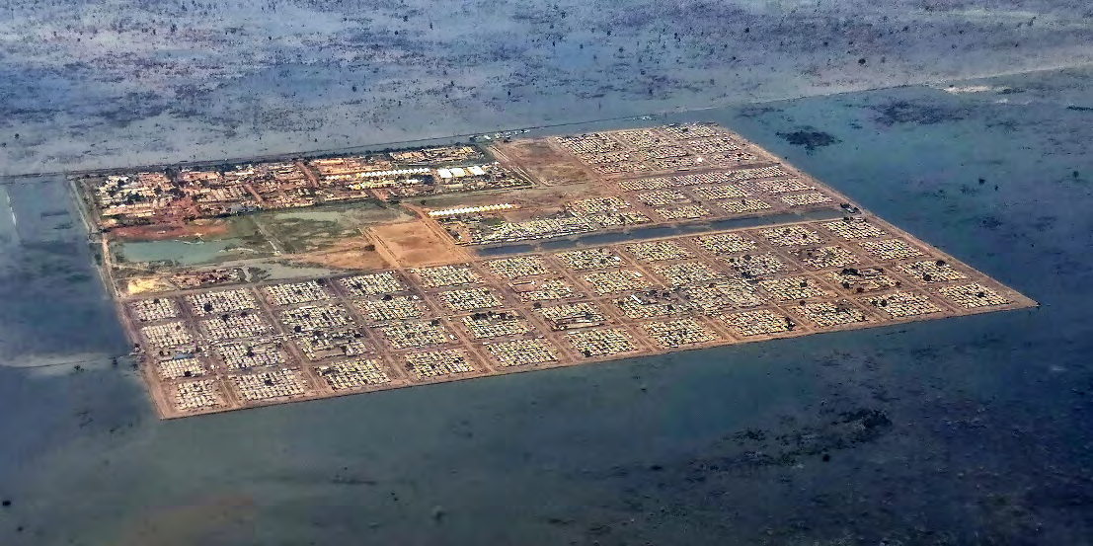

Flood waters surrounding Bentiu camp, protected by dykes (October 2022). Credit: UNICEF/Dara Johnston

Early investments in latrines, water treatment sites, and cholera vaccine campaigns helped to avert a public health emergency, with the country able to

5 E. Easton-Calabria, [Acting in Advance of Flooding: Early Action in South Sudan, A Feinstein International Center Brief](https://reliefweb.int/report/south-sudan/acting-advance-flooding-early-action-south-sudan), 2023.

**5**

maintain a case fatality rate from cholera of less **“On the whole the money that**

than 1 percent.**6**  **came in helped quite a bit with**

Cash transfers to over 1,000 female-headed house-holds, the majority of whom had at least one family member who was elderly or with a mobility im-  
pairment, enabled them to reinforce their shelters. Before the floods, at least 93 percent of households reported water entered their shelter when it rained.

After making the investment in their shelters, this decreased to 42 percent in one camp and less than 12 percent in the other two camps at the height of the rainy season.**7**

The early allocation of CERF and SSHF funds was catalytic. It rang the alarm bell, mobilizing earlier funding from donors and action from humanitarian partners.**8**

**mitigation for flooding...**

**Other locations in the camp set up dike committees and trained people immediately. Materials were bought, and tools, and**   
**people were able to use the tools to reduce flooding in their sites.”**

*– UNHCR informant***9**

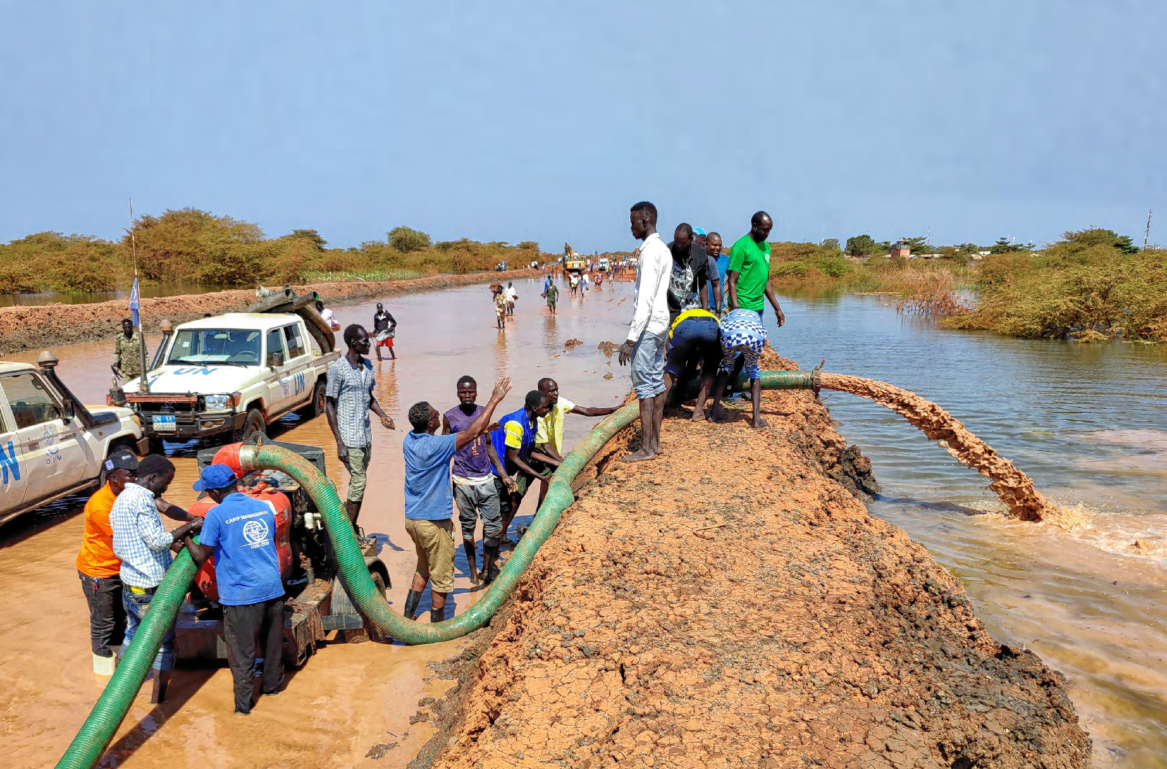

Road recovery: dewatering in process after dike breach along the UNMISS-Rubkona Road 2022. Credit: IOM/Joshua Kanyara

6 OCHA, [CERF Allocation Report on The Use of Funds and Achieved Results - South Sudan Rapid Response for Flood, 2022](https://cerf.un.org/sites/default/files/resources/22-RR-SSD-52855_South%20Sudan_CERF_Report.pdf).

7 International Security Development Center, Impacts of Early Action Support on lives and livelihoods in South Sudan: The Life in Bentiu Study, 2023. 8 OCHA, [CERF Allocation Report on The Use of Funds and Achieved Results - South Sudan Rapid Response for Flood, 2022](https://cerf.un.org/sites/default/files/resources/22-RR-SSD-52855_South%20Sudan_CERF_Report.pdf).

9 E. Easton-Calabria, [Acting in Advance of Flooding: Early Action in South Sudan, A Feinstein International Center Brief](https://reliefweb.int/report/south-sudan/acting-advance-flooding-early-action-south-sudan), 2023.

**6**

**The take-away**

This example from South Sudan demonstrates that over three years, releasing some $90 million in

in protracted crises and conflict settings, where funding.

forecasting data is often less reliable, it is still

possible for the humanitarian community to take anticipatory action based on risk and vulnerability.

Anticipatory action may work best when there   
is a framework with a pre-agreed trigger for pre-arranged funding and activities. But sometimes there is not enough time, data, or access to develop such a framework. South Sudan shows this should not stop humanitarians from acting to mitigate the impact ahead of an expected shock. Anticipatory principles can be taken and adapted to context-appropriate programmes.

South Sudan also illustrates that continuous learning and improvement is a bedrock for

“The pilots helped the humanitarian community to learn what works and what doesn’t. They   
contributed to a mind shift in the humanitarian community, creating a higher level of understanding and acceptance for acting ahead of a predictable or forecasted shock. Senior leaders and donors trust the analysis provided by the Centre and   
the pilots have given them more confidence to   
make decisions and fund based on risk,” said   
Lisa Doughten, Director of OCHA’s Financing and Partnership Division.

OCHA continues to facilitate coordinated   
anticipatory action and has expanded its portfolio of pre-arranged funding to more than $100 million

innovation. in 15 countries for storms, floods, droughts and cholera.

As of 2 January 2024, OCHA has facilitated   
collective anticipatory action pilots in 19 countries

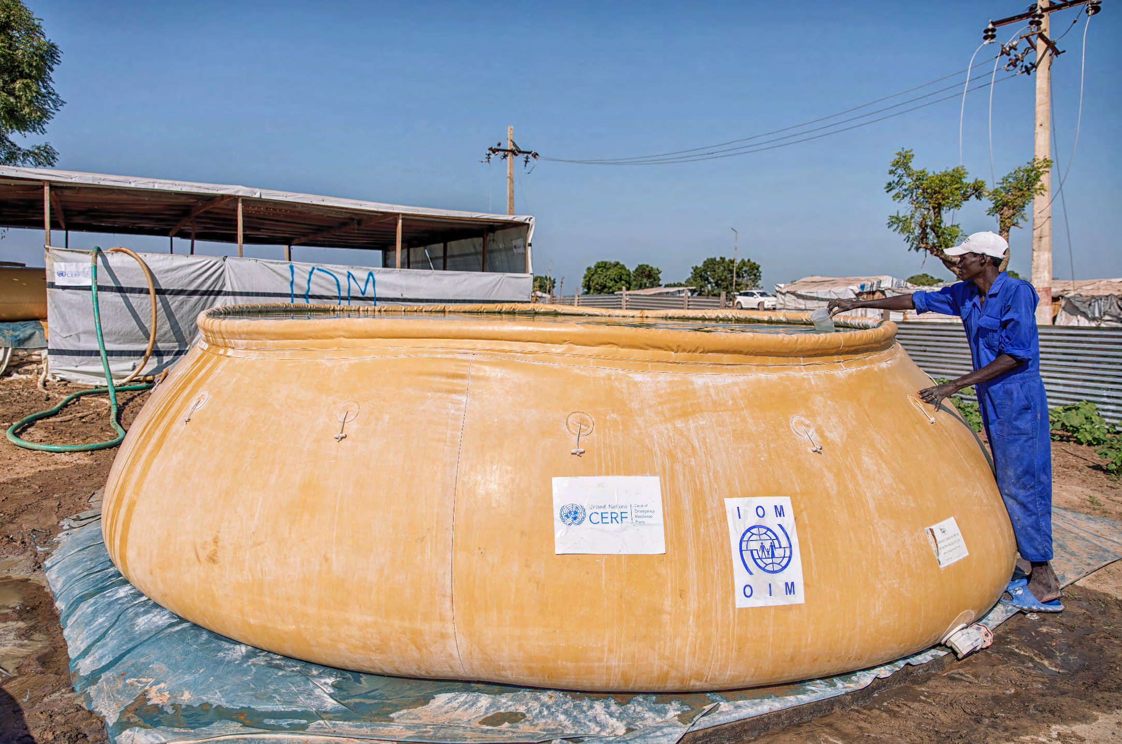

A man checks the water at a surface water treatment system (SWAT) water point for displaced people at Bentiu IDP site A in Bentiu town. The water point is run by IOM serves over 15,000 IDPs in the area. Credit: OCHA/Sarah Waisna

**7**

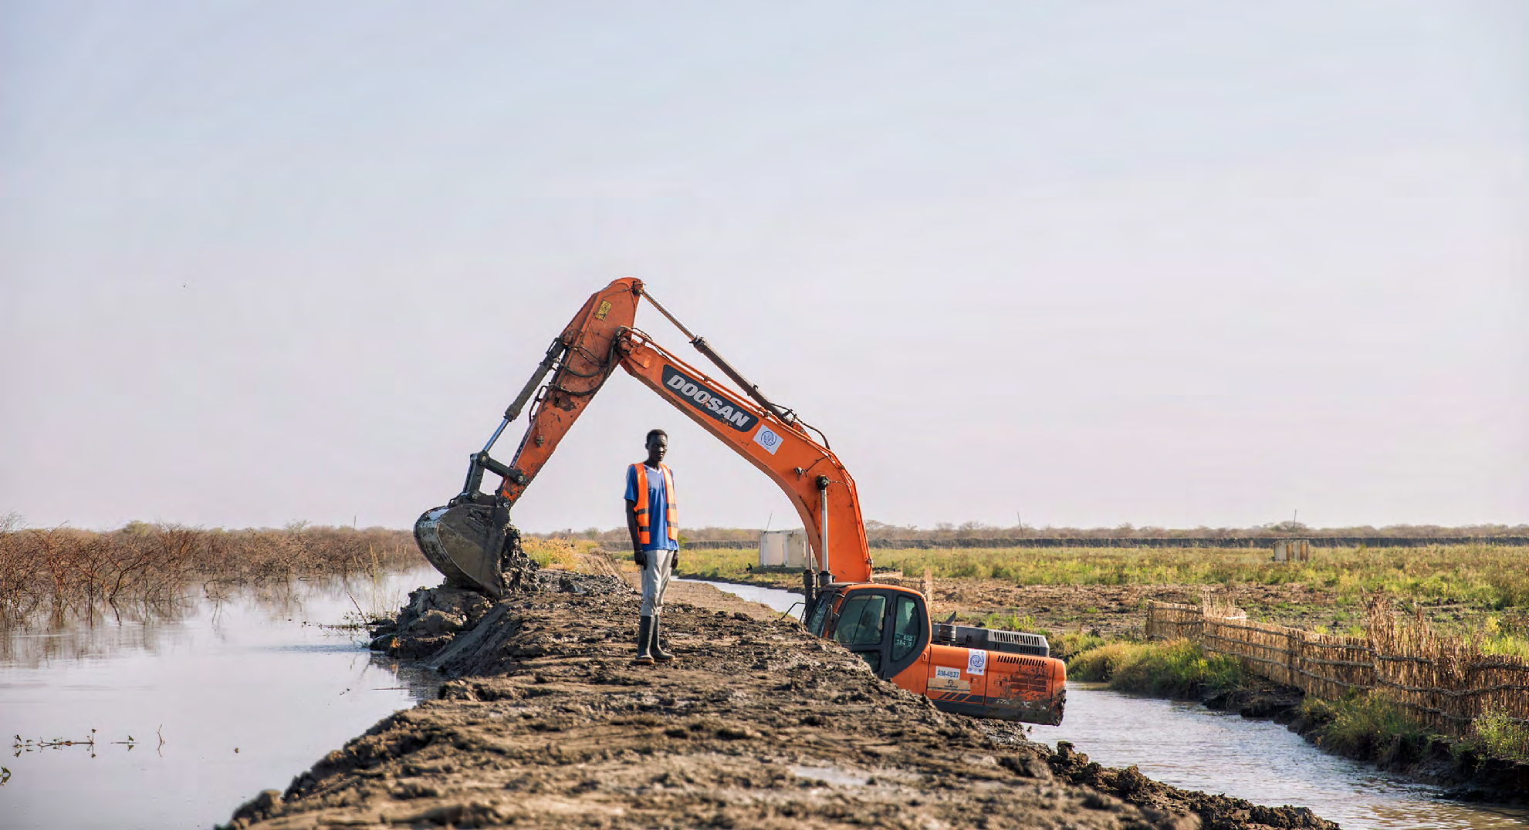

IOM team construct new dykes in Bentiu Jedit, Bentiu town in Rubkona Country. The construction work is funded by the Central Emergency Response Fund. Credit: OCHA/Sarah Waisna

CERF is also inviting applications for funding anticipatory action to get ahead of predictable

aims to continue to mobilize pre-arranged financing and resources for anticipatory or early action.

humanitarian impacts of El-Niño-driven climate

emergencies.“With an overstretched global system, scaling up anticipatory action remains a top priority for OCHA. This involves advancing analysis on

Overall, the humanitarian community considers the pilot in South Sudan a success, but with an acute awareness that anticipatory action by itself will

the approach and the related opportunity costs,” never be enough.

said Joyce Msuya, Assistant Secretary-General for   
Humanitarian Affairs and Deputy Emergency Relief By the end of the 2022 rainy season in South Sudan, Coordinator. several dykes had burst and homes that had been temporarily repaired were beginning to leak again.

OCHA’s Centre for Humanitarian Data is also build-ing on valuable lessons from South Sudan, expand-ing its work on risk analysis to support early action

There is an urgent need for longer-term disaster risk reduction and development to support the people of South Sudan to endure these increasingly severe

in other contexts. climatic events.

To translate technical information into actionable in-formation for humanitarians, the Centre is expand-ing its work on flood anticipatory action. In partner-ship with Google’s Flood Forecasting Initiative, the Centre is piloting flood early warning across the Niger and Benue river systems to provide automat-ic alerts to decision makers when flood levels are forecasted or observed to rise.

By linking analysis to decision makers and funding — like the CERF and implementing partners — OCHA

As observed by one humanitarian partner: “What we’re doing is mitigating the worst humanitarian im-pact for people. But if we don’t have a real climate adaptation programme, where we really look at in-frastructure, roads, dykes, and longer-term areas to protect, like water systems reinforced, we will con-tinue to have massive humanitarian consequences…Our action is meant to be limited in time, but here [in South Sudan] it is the only action taken.”**10**

**For the people in Bentiu, that action was critical.**

10 E. Easton-Calabria, [Acting in Advance of Flooding: Early Action in South Sudan, A Feinstein International Center Brief](https://reliefweb.int/report/south-sudan/acting-advance-flooding-early-action-south-sudan), 2023.

**8**